**Prediction and analysis of state exams via the use of decision trees**

|  |  |  |  |
| --- | --- | --- | --- |
| Simón Cárdenas Villada  Universidad Eafit  Colombia  scardenasv@eafit.edu.co | Juan Pablo Yepes Universidad Eafit  Colombia  jpyepesg@eafit.edu.co | Miguel Correa Universidad Eafit Colombia macorream@eafit.edu.co | Mauricio Toro  Universidad Eafit  Colombia  mtorobe@eafit.edu.co |

**Summary:**

The objective of this project is that, through decision trees, a prediction is generated, which, it helps a student (who has previously submitted the tests saber 11o) to know whether in the future will get a higher than average grade in state tests or test saber pro.

This situation has a large number of variables, which can positively or negatively affect the result in the tests, so it is of the utmost importance to study all these variables thoroughly, in order to obtain a reliable prediction. This problem is of paramount importance as this allows us to measure the level of education in a country in one way or another and study how external factors such as sociodemographic factors may or may not affect test results. This project has different related problems, for example, the sociodemographic situation of the student. These will be resolved in the next few verbatim.

## **Keywords**

|  |
| --- |
| Decision trees, machine learning, academic success,  prediction of test results |

**1 Introduction:**

Today a good education is sought for all people, however, this is affected by external factors such as corruption, social situation, among others. These factors often affect the student's academic success as they have a great influence on the learning method, and as such the pace of learning that the student can carry.

This problem is evident in large numbers in Latin American or Central American countries as corruption and poverty abound, so students do not have the right and necessary materials for adequate learning, thus creating a direct impact on the results of state tests, both in the tests saber 11th and in the tests saber pro. This project will create a decision tree capable of predicting whether a student will get an above-average score on the test to saber pro, taking into account different factors.

**1.1 Problem:**

The problem for this project is to predict whether a student will get a higher-than-average grade on the test to know pro. As explained above, this situation has a big impact on society as it is essential for human beings to have a good education, however, this is affected by many external factors. Creating a solution to this problem would be very useful in society, because, based on the results of the algorithm, the state will be able to keep quality control in middle education easier and more efficient.

**1.3 Structure of the article**

In the following, in section 2, we present the work related to the problem. Later, in section 3, we present the datasets and methods used in this research. In section 4, we present the design of the algorithm. Then, in section 5, we present the results. Finally, in section 6, we discussed the results and proposed some future working directions.

**2.1 Predictive and incremental validity of self-regulation skills on academic success at the university**

"This paper analyzes the predictive and incremental validity of self-regulatory skills on academic success at university through the follow-up of 218 students over four academic courses. " (García & Perez Gonzalez, 2011)

This paper selected 218 students as an experimental publication and took into account variables such as: pre-entry education at the university and sociodemographic variables.

In this work they presented two models, one called RAP-1 and one RAP-3.

It can be said that the accuracy achieved was good as the models showed a result according to the variables they took into account.

# **2.2 Predicting academic performance: linear regression versus logistic regression**

In this report they seek to evaluate the capacity of linear regression and logistic regression in predicting performance and academic success/failure, based on variables, such as attendance and class participation, which is very useful in the project to be developed as they show analysis by logistic regression, giving good accuracy in the results of the report. The project "Predicting Academic Performance: Linear Regression versus Logistic Regression” states that the best predictor of future academic performance is the previous performance “

**2.3 PREDICTING STUDENTS’ ACADEMIC PERFORMANCE: COMPARING ARTIFICIAL NEURAL NETWORK, DECISION TREE AND LINEAR REGRESSION**

Predicting students’ academic performance is critical for educational institutions because strategic programs can be planned in improving or maintaining students’ performance during their period of studies in the institutions. The result of this study shows that all of the three models produce more than 80% accuracy. It also shows that artificial neural network outperforms the other two models.

206 students’ data were obtained for this study

# **2.4 Student Academic Performance Prediction Model Using Decision Tree and Fuzzy Genetic Algorithm**

This work aims to develop students academic performance Prediction model using two selected classification methods; Decision three and fuzzy genetic algorithm.

The algorithm used to implement decision tree is the C4.5 algorithm.

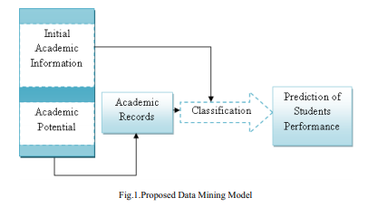

The results returned by both the decision tree and the fuzzy genetic algorithm were different, but it is not speceficed if a method was more accurate than the other.

## **3.1 Data collection and processing**

We obtained data from *the Colombian Institute for the Promotion of Higher Education* (ICFES), which are available online at ftp.icfes.gov.co. This data includes anonymized results from Saber 11 and Saber Pro. Saber 11 results were obtained from all Colombian high school graduates, from 2008 to 2014, and Saber Pro results from all Colombian undergraduate graduates, from 2012 to 2018. There were 864,000 records for Saber 11 and 430,000 for Saber Pro. Both Saber 11 and Saber Pro included not only the scores but also the socioeconomic data of the students, collected by the ICFES, before the test.

In the next step, both datasets were merged using the unique identifier assigned to each student. Therefore, a new dataset was created that included students who took both standardized tests. The size of this new dataset is 212,010 students. The binary predictor variable was then defined as follows: Is the student's score in The Saber Pro higher than the national average of the period in which he took the test?

It was discovered that the datasets were not balanced. There were 95,741 students above average and 101,332 below average. We perform a subsampling to balance the dataset by a ratio of 50%-50%. After subsampling, the final data set had 191,412 students.

Finally, to analyze the efficiency and learning rates of our implementation, we randomly create subsets of the primary dataset, as shown in Table 1. Each dataset was divided into 70% for training and 30% for validation. Datasets are available in [https://github.com/mauriciotoro/ST0245-Eafit/tree/master/proyecto/datasets.](https://github.com/mauriciotoro/ST0245-Eafit/tree/master/proyecto/datasets)  .

|  |  |  |  |  |  |
| --- | --- | --- | --- | --- | --- |
|  | **Data set 1** | **Data set 2** | **Data set 3** | **Data set 4** | **Data set 5** |
| **Training** | 15,000 | 45,000 | 75,000 | 105,000 | 135,000 |
| **Validation** | 5,000 | 15,000 | 25,000 | 35,000 | 45,000 |

**ID3**

ID3 is an algorithm invented by Ross Quinlan in 1986. It is used to generate a decision tree from a specified dataset. The algorithm starts with the dataset as the root and with each iteration it cycles trough every unused attribute of the set calculating the information gain of said attribute. After this the attribute with the highest information gain is chosen and the set is split to generate subsets of data until all data has been processed into a node.

Time complexity: *O*(*h*), where h is the height of the tree.

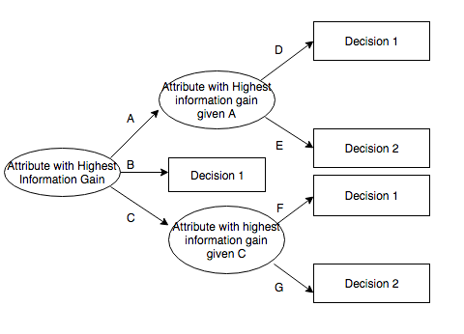

*https://upload.wikimedia.org/wikipedia/commons/thumb/4/46/ID3_algorithm_decision_tree.png/220px-ID3_algorithm_decision_tree.png*

**C4.5**

C4.5 is an algorithm invented by Ross Quinlan as an extension to ID3. The main use of C4.5 is to generate decision trees to classify data and it is utilized extensively as a statistical sorting tool. It uses a training dataset in the same way that ID3 does by using information entropy. In each node of the tree the algorithm determines an attribute to divide the set into subsets based on the information gain the attribute has, after this it recursively divides everything into smaller subsets.

C4.5 has some improvements over ID3, such as being able to manage continuous and discrete attributes and allowing to set attribute values as missing so the algorithm ignores this in the entropy and gain calculations.

Time complexity: *O(|E|log|V|*)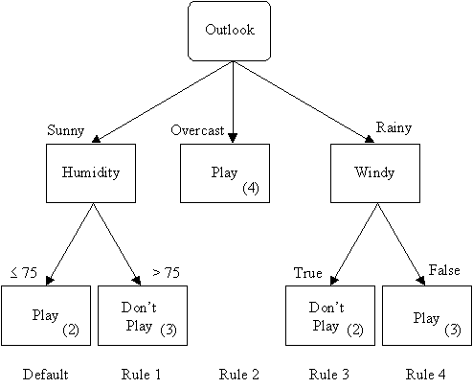

*http://www2.cs.uregina.ca/~dbd/cs831/notes/ml/dtrees/c4.5/golftree.gif*

**CHAID**

The CHAID algorithm was first introduced by Kass in 1980 and is based primarily on chi-squared statistics, this means that the test yields a value between 0 and 1 indicating the difference between two classes.

The algorithm by default Uses Bonferroni adjustment control and determine the size of the final tree. Its main differentiating factor is that it uses multiway splits at each node, therefore, it can produce multiple branches with only a single parent node. Depending on the statistical significance of each category CHAID will determine an alpha-to-split and an alpha-to-merge to process all categories.The algorithm will continue iteratively until it finds that there are no more splits possible given the alpha values.

Time complexity: O(mn log n)

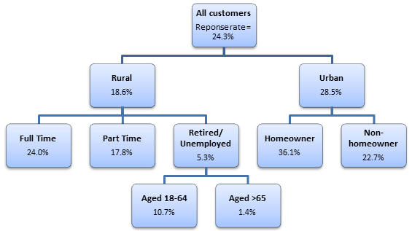

[*https://select-statistics.co.uk/wp-content/uploads/2015/11/chaid-tree-diagram.png*](https://select-statistics.co.uk/wp-content/uploads/2015/11/chaid-tree-diagram.png)

**CART**

CART was introduced by Breiman in 1984. This algorithm produces only binary splits unlike CHAID and its based on the principles of purity and balance, this means that a CART decision tree should have equal population on each side of the root. Forcing this balance can lead to some sacrifices in the purity of the nodes and can also increase demand in computational resources but the trees are taller and less wide than the ones made with CHAID.

The recursive splitting procedure of the algorithm stops when it detects no further gain can be made, or some pre-defined stopping rules are met.

Time complexity: O(v⋅nlogn)

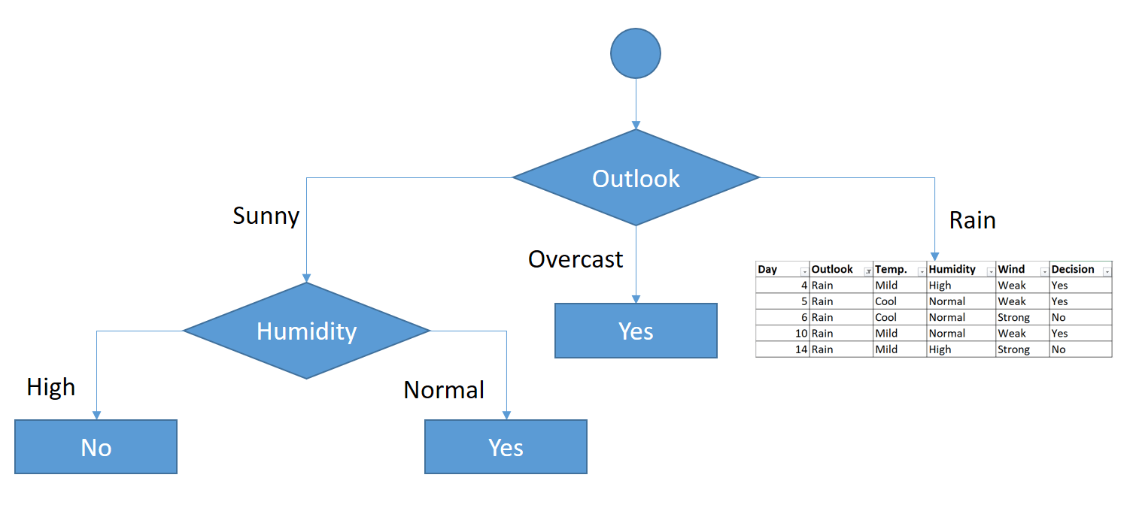

[*https://i0.wp.com/sefiks.com/wp-content/uploads/2018/08/cart-step-4.png?ssl=1*](https://i0.wp.com/sefiks.com/wp-content/uploads/2018/08/cart-step-4.png?ssl=1)

**References**

1. García Jiménez, María. And Alvarado Izquierdo, Jesús. And Jiménez Blanco, Amelia. La predicción del rendimiento académico: regresión lineal versus regresión logística. Psicothema, Oviedo, 2000
2. García, Rafael. And Pérez González, Francisco. Validez predictiva e incremental de las habilidades de autorregulación sobre el éxito académico en la universidad. Revista de psicodidactica, Vitoria-Gasteiz,2011
3. Ibrahim, Zaidah. And Rusli, Daliela. Predicting Students' Academic Performance: Comparing Artificial Neural Network, Decision Tree and Linear Regression. Research gate, Kuala Lumpur, 2007
4. Hamsa,Hashmia. And Indiradevi, Simi. Student academic performance Prediction model using decision tree and fuzzy genetic algorithm. Elsevier ltd, Pathanamthitta, 2016